**Build and Deploy Custom Connector**

1. Sign into the Power Apps or Power Automate

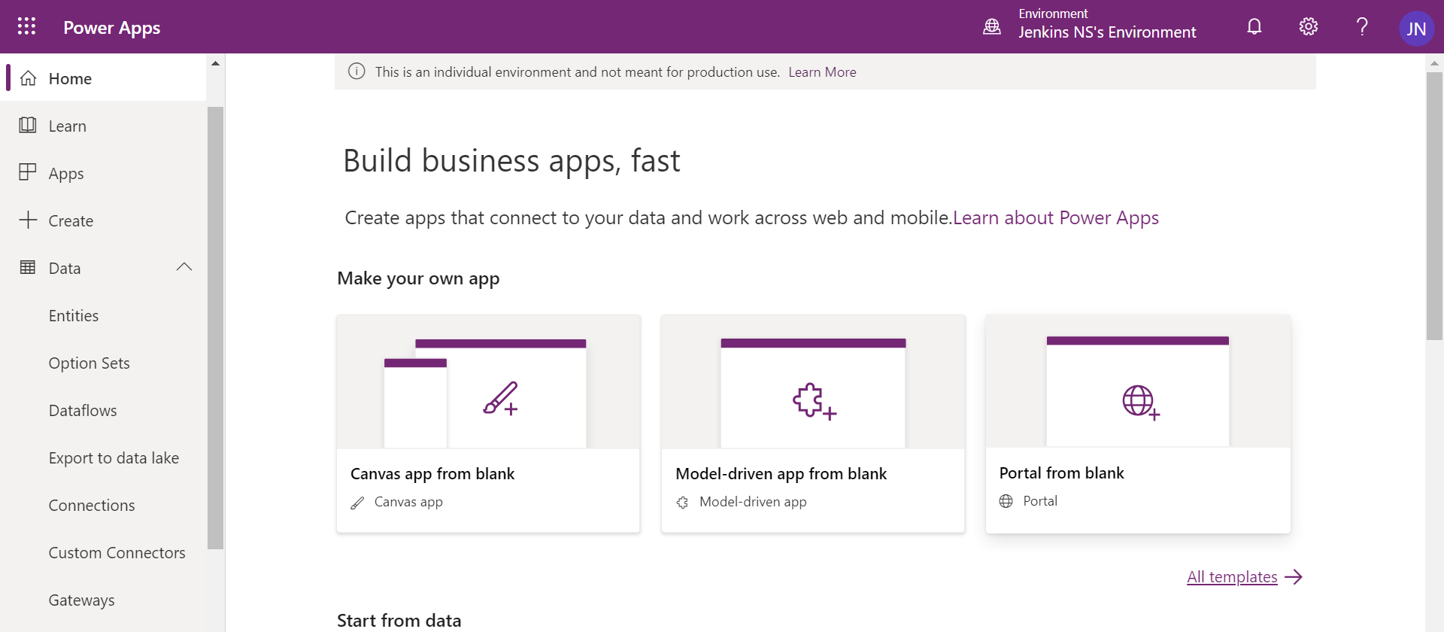

1. Click Custom Connectors under Data

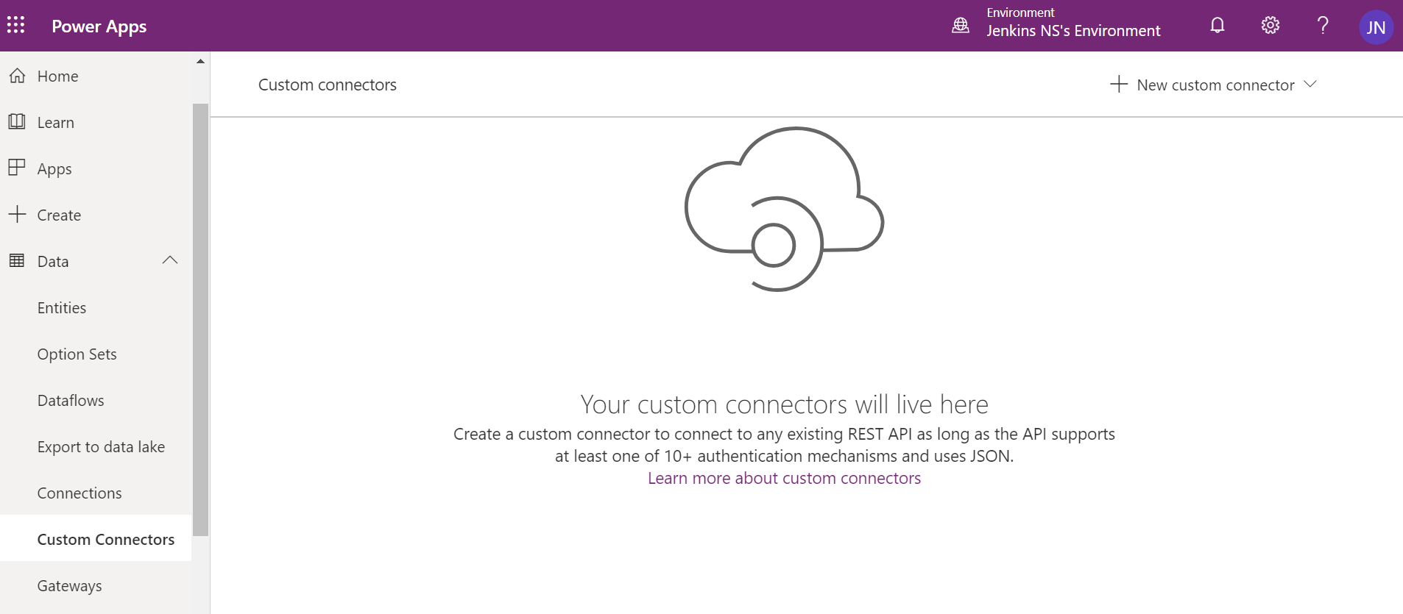

1. Click ‘New Custom connector’ in the right-hand side.

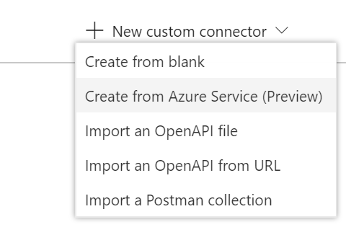

1. Select Create from blank
2. Give name for the connector
3. GetGoogleBooks

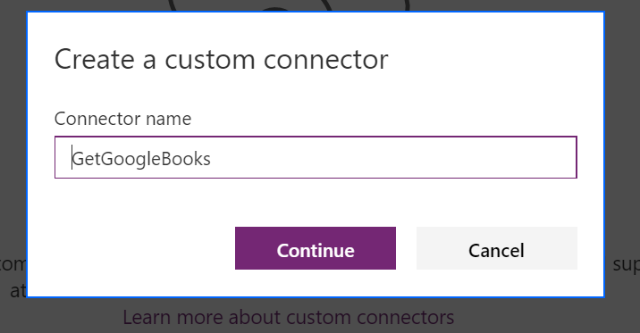

1. It will open Create connector page

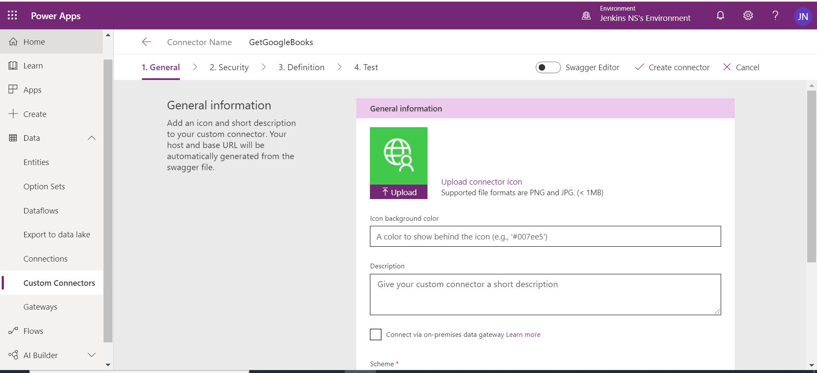

1. Fill the General Information
2. Upload logo for the connector
3. Set the background color
4. Give proper description about your connector

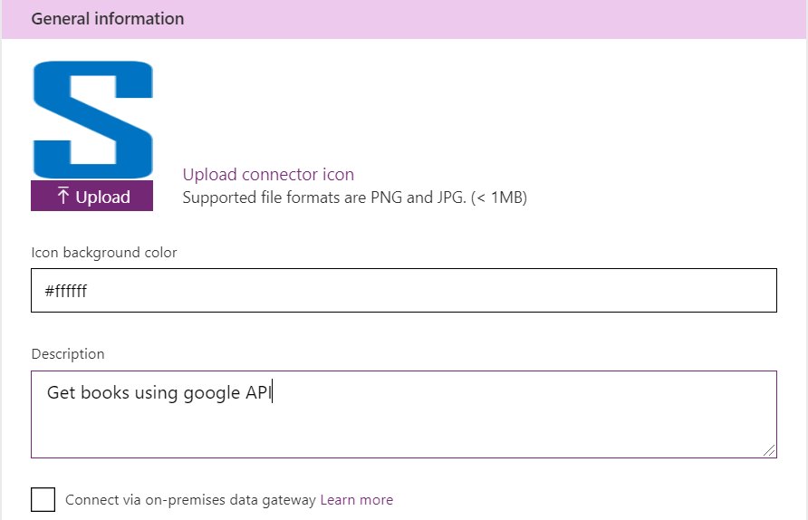

1. Scheme HTTPS
2. Host *: www.googleapis.com
3. Base URL: /books/

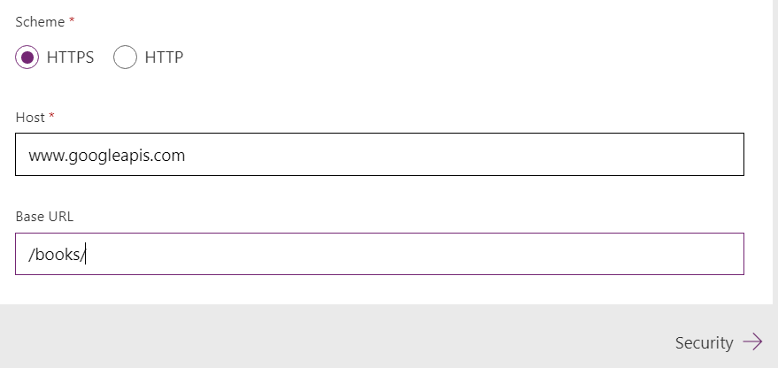

1. Click Security to move next section ‘Security’

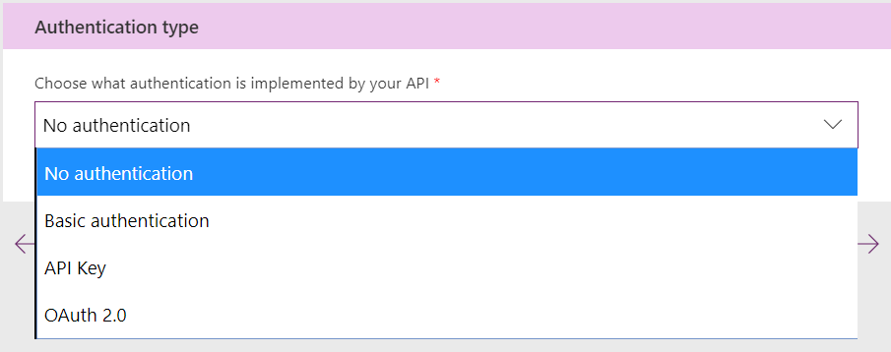

1. Select ‘No authentication’ for our lab exercise, because we are using open API
2. Click ‘Definition’ to move next section

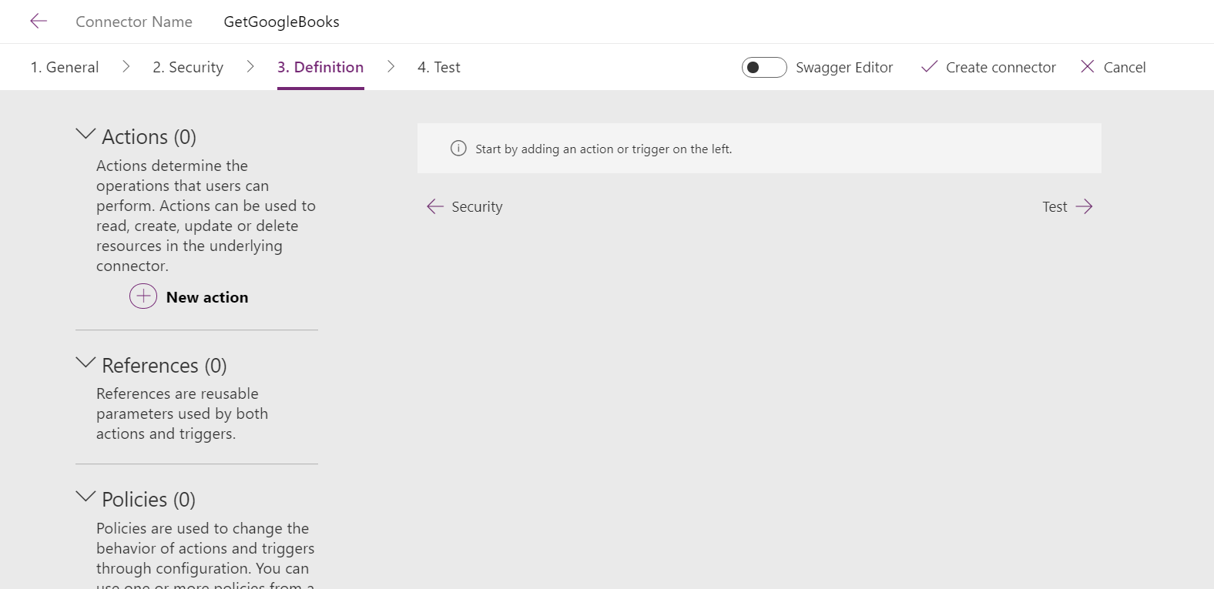

1. Add New Action
   1. Add Definition
      1. Summary: Get Books Names
      2. Description: get Books using google API
      3. Operation ID *: GetBooks
      4. visibility – none

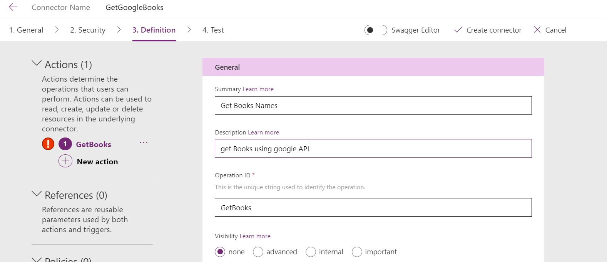

* 1. Add request - Click Import from sample
     1. Verb – Get
     2. Url- <https://www.googleapis.com/books/v1/volumes?q=>
     3. Click import to create request

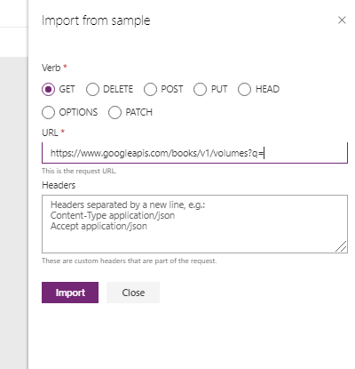

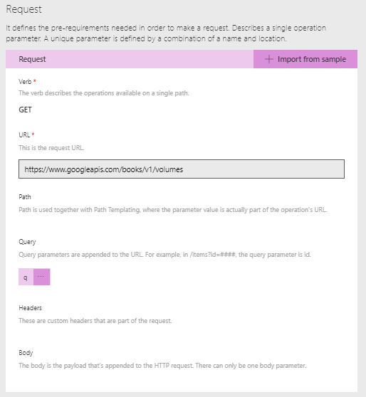

1. Add Response schema: Click default Response link

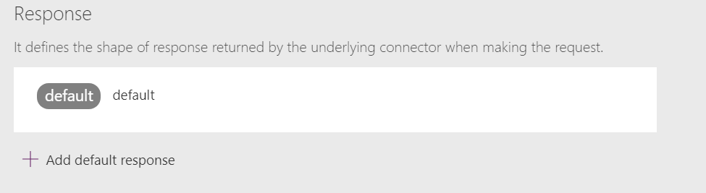

1. Click import from sample

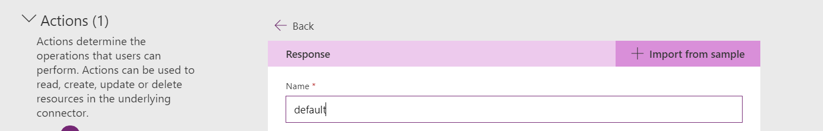

1. Open this URL in chrome browser and copy the whole response from the browser : <https://www.googleapis.com/books/v1/volumes?q=ISBN:9780789748591>
2. Paste in the body control

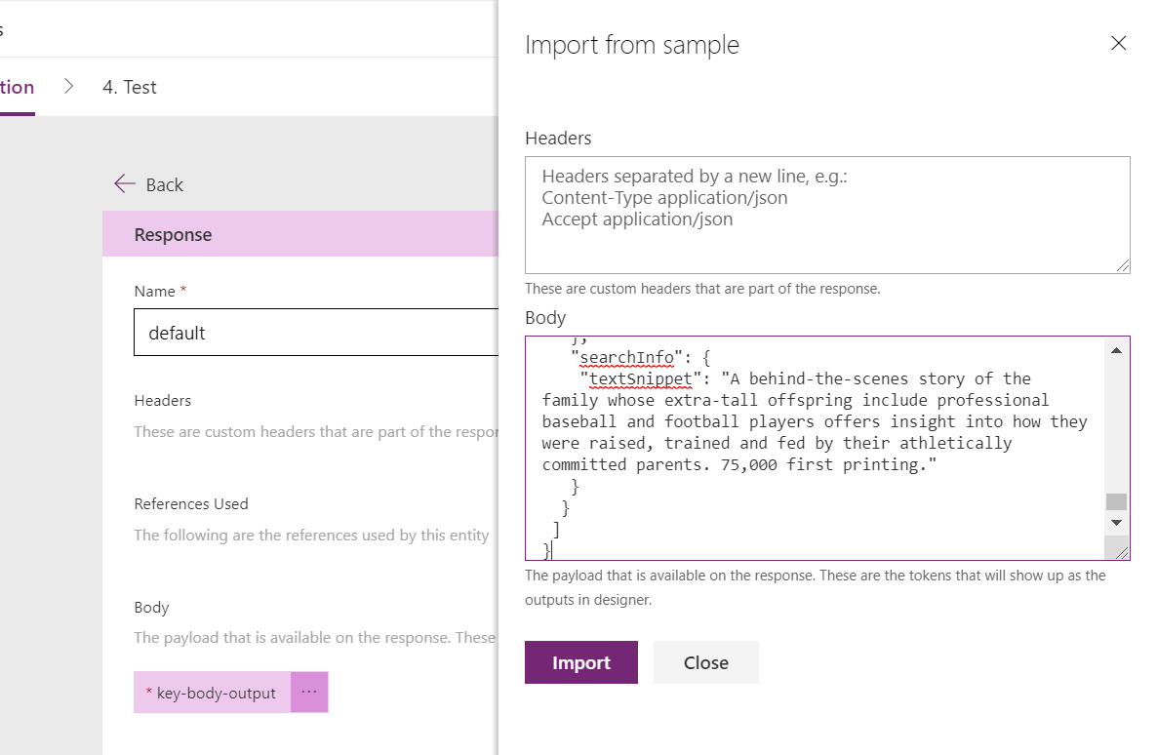

1. Click import and set schema to response

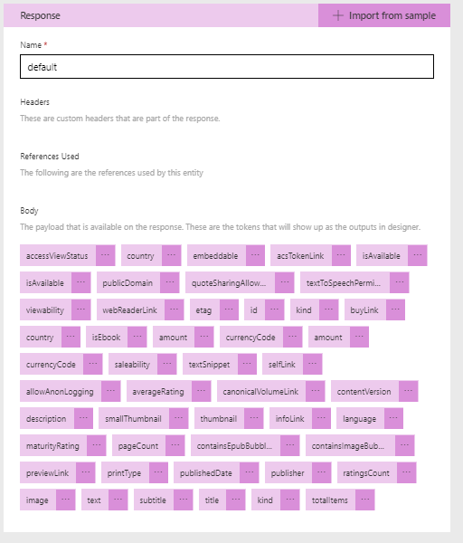

1. Click ‘Create connector’ to create the connector



1. Click Test to test the connector
   1. Create New connection

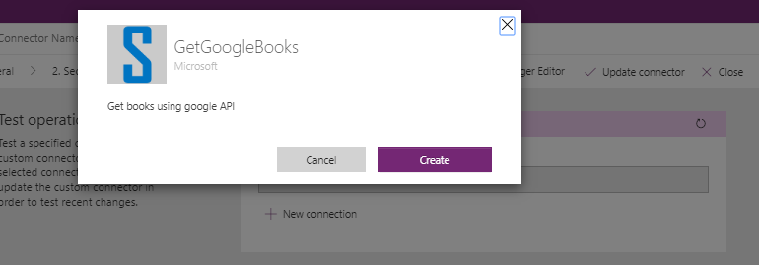

* 1. Test the connector give parameter : [ISBN:9780789748591](https://www.googleapis.com/books/v1/volumes?q=ISBN:9780789748591)

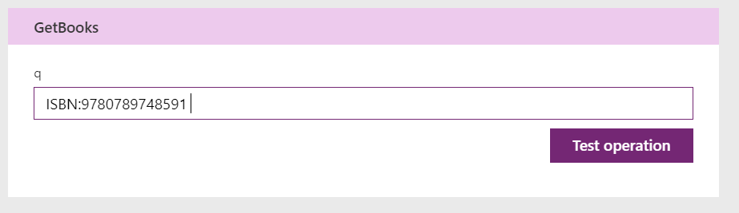

* 1. It will reply the response with 200 status

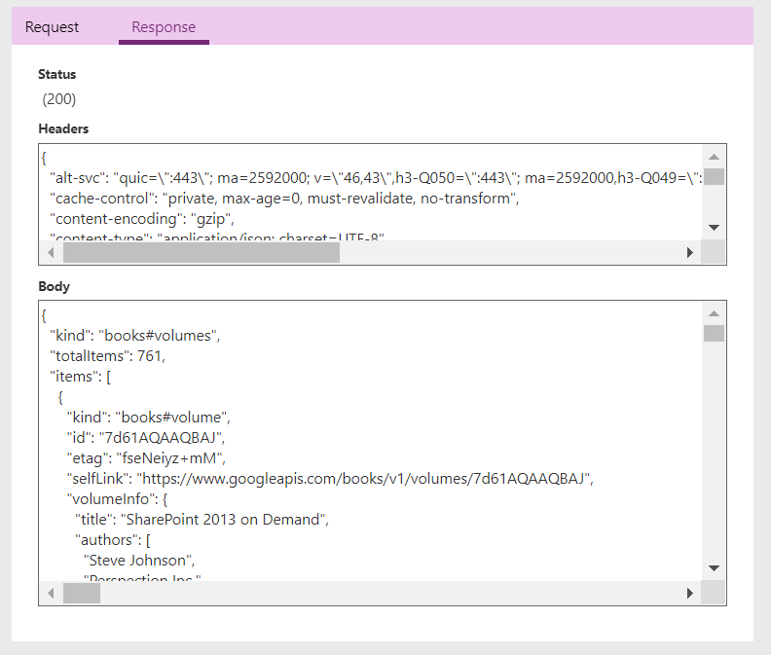

Custom Connector Implementation

Steps to follow: -

1. Create Instant flow as trigger
2. Add input to get ISBN number
3. Add custom connector as action
4. Assign the ISBN input value
5. Add another action to convert as HTML
   1. Assign the items object
   2. Customise the HTML form
   3. Select columns as custom and Add header and value from dynamic content
      1. Same as Lab 11 step 9
6. Add another action to send email with HTML output

